**WILD PLANTS EDIBILITY PREDICT USING IBM WATSON STUDIO**

A Mini Project report submitted to

#### JAWAHARLAL NEHRU TECNOLOGICAL UNIVERSITY, HYDERABAD

In partial fulfillment of the requirements for the award of the degree of

#### BACHELOR OF TECHNOLOGY

In

#### COMPUTER SCIENCE AND ENGINEERING

Submitted By

**MUPPALA KEERTHANA 18UK1A0534**

**BOURISHETTY SWETHA 18UK1A0556**

**KALERU NARESH 18UK1A0538**

**BHUKYA SANTHOSH 18UK1A0507**

Under the guidance of

#### Mr. SHIVA SAI PRASAD

Assistant Professor



**DEPARTMENT OF COMPUTER SCIENCE AND ENGINEERING VAAGDEVI ENGINEERING COLLEGE**

Affiliated to JNTUH, HYDERABAD BOLLIKUNTA, WARANGAL (T.S) - 506005

### DEPARTMENT OF COMPUTER SCIENCE AND ENGINEERING VAAGDEVI ENGINEERING COLLEGE

**WARANGAL**



**CERTIFICATE**

This is to certify that the Mini project report entitled “ **WILD PLANTS EDIBILITY PREDICTION USING IBM WATSON STUDIO”** is being submitted by **MUPPALA KEERTHANA(18UK1A0534), BOURISHETTY SWETHA(18UK1A0556) , KALERU NARESH(18UK1A0538) , BHUKYA SANTHOSH(18UK1A0507** in partial fulfillment of the requirements for the award of the degree of Bachelor of Technology in Computer Science & Engineering to Jawaharlal Nehru Technological University Hyderabad during the academic year 2021- 2022.

#### Project Guide HOD

**Mr.** **SHIVA SAI PRASAD Dr. R. NAAVEN KUMAR**

**EXTERNAL**

**ACKNOWLEDGEMENT**

We wish to Jake this opportunity to express our sincere gratitude and deep sense of respect to our beloved **Dr. P. Prasad Rao**, Principal, Vaagdevi Engineering College for making us available all the required assistance and for his support and inspiration to carry out this mini project in the institute.

We extend our heartfelt thanks to **Dr. R. Naveen Kumar**, Head of the Department of CSE, Vaagdevi Engineering College for providing us necessary infrastructure and thereby giving us freedom to carry out the mini project.

We express heartfelt thanks to the Mini Project Coordinator, **Dr. J. Srikanth**, Assistant Professor, Department of CSE for his constant support and giving necessary guidance for completion of this mini project.

We express heartfelt thanks to the guide, **Mr. SHIVA SAI PRASAD**, Assistant Professor, Department of CSE for his constant support and giving necessary guidance for completion of this mini project.

Finally, we express our sincere thanks and gratitude to our family members, friends for their encouragement and outpouring their knowledge and experiencing throughout thesis.

### ABSTRACT

The rural communities of developing countries depend on wild edible plants to meet their food requirements during periods of food shortage. Wild edible plants are mostly serving as supplementary foods in different parts of the world because they are nutritionally rich and can supplement especially vitamins and micronutrients. The main objective of this project is to build Convolutional neural networks are a deep model to detect and classify the edibility of the wild plant. The model also suggests the effects of non-edible wild plant produce.

We are creating a web application where the user selects the image which is to be classified. The image is fed into the model that is trained and the predicted class will be displayed on the webpage.

## TABLE OF CONTENTS:-

1. INTRODUCTION………………………………………………………………13

OVERVIEW………………………………………………………………….1

* 1. OBJECTIVE OF PROJECT 2
  2. PURPOSE 3

1. PROBLEM STATEMENT 3
2. LITERATURE SURVEY 3-5
   1. EXISTING SYSTEM 3-4
   2. PROPOSED SOLUTION 4-5
3. EXPERIMENTAL ANALYSIS 5-8
   1. BLOCKDIAGRAM 6
   2. USECASE DIAGRAM 6
   3. SOFTWARE REQUIREMENTS 7
   4. HARDWARE REQUIREMENTS
4. DESIGN 10-17
   1. IBM CLOUD ACCOUNT 7-14
   2. DATASET PRE PROCESSING 15-16
   3. MODEL BUILDING 15-16
5. FLOW CHART 17-18
6. CODE SNIPPETS………………………………………………………………………20

MODEL CODE………………………………………………………………………….

HTML CODE………………………………………………………………………….

1. CONCLUSION 20
2. APPLICATIONS 20
3. ADVANTAGES 20
4. DISADVANTAGES………………………………………………………………..24
5. FUTURESCOPE……………………………………………………………………24

#### BIBILIOGRAPHY 24

**LIST OF FIGURES PAGE NO.**

Figure 1: Training and testing using Histapathological images with CNN 2

Figure 2: Project Architecture 3

Figure 3: Use case diagram 4

Figure 4: Flow chart 7

Figure 5:ipynb code for importing the libraries and image data augmentation 10

Figure 6: ipynb code describing the loading data performance 11

Figure 7: .ipynb code of augmentation 11

Figure 8: .ipynb code compiling the building model 12

Figure 9: ipynb of compiling the model building 13

Figure 10: ipynb code of model building 13

Figure 11: compiling the model 14

Figure 12: fit the model 14

Figure 13: predicting the model 15

Figure 14: ipynb code of saving the mode 15

Figure 15: ipynb code of saving model 16

Figure 16: styling the bodytag 16

Figure 17:ipynb code of predicting our result 18

Figure 18:predicting our code result 19

Figure 19:HTML Index Code 19

Figure 20: HTML index webpage 20

Figure 21: html index code 20

Figure 22:html index webpage code 21

Figure 23:wild plants produce edibility prediction 22

Figure 24:to ensure good health and edible and non edible plant 22

Figure 25:edible and non edible plants 22

Figure 26:edible and non edible plants of eat lightly 23

**1.INTRODUCTION**:

**1.1 Overview:**

The rural communities of developing countries depend on wild edible plants to meet their food requirements during periods of food shortage. Wild edible plants are mostly serving as supplementary foods in different parts of the world because they are nutritionally rich and can supplement especially vitamins and micronutrients. The main objective of this project is to build Convolution neural networks are a deep model to detect and classify the edibility of the wild plant. The model also suggests the effects of non-edible wild plant produce.

We are creating a web application where the user selects the image which is to be classified. The image is fed into the model that is trained and the predicted class will be displayed on the webpage.

**1.2 PURPOSE:**

By using wild plants eligibility prediction using IBM Watson studio we will:

* We know the concepts and can work on IBM Watson studio.
* Wild edible plants are mostly serving as supplementary foods in different parts of the world because of the nutritionally rich and can supply the vitamins and micronutrients
* The main objective of this project is about the model suggests of non-edible wild plant production.

### 2.PROBLEMSTATEMENT:-

* Wild plant food often has the vegetable kingdom suitable by nature for use of food, especially by human beings .
* Not all parts of any given plants have been know the people.

### 

## 3.LITERATURE SURVEY:-

### 3.1 EXISTING SYSTEM:

Prediction of edibility of wild plants by classifying the input image of various wild plants on organization of wild plants is stems are one part of plants that are eaten by humans .Most plants are made up of roots ,stem ,leaves. The most commonly edible parts of plants are fruits ,usually sweet ,fleshy and sufficient. The most cultivated for their value and referred to as vegetables. Wild plants are nutrionally rich and can supplement especially vitamins and micronutrients.

### 3.2 PROPOSED SOLUTION:

We are creating a web application where the user selects the image which is to be classified. The image is fed into the model that is trained and the predicted class will be displayed on the webpage.

our method employs the IBM Watson studio prediction modelfor accurate identification of edibility of wild plants to detect the plants belongs to appropriate class.

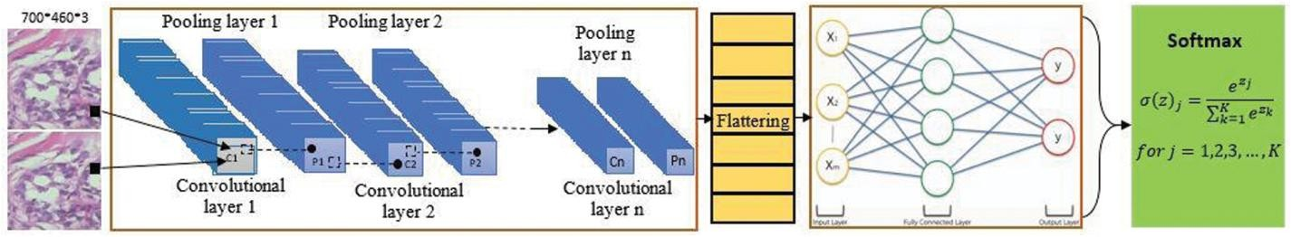

#### Figure 1: Training and Testing using Histopathological images with CNN

These filters scan the image by a sliding window on the image, while learning the recurrent patterns which arise in any area of the image. The interval between filters is known as the stride. The convolution is extended to overlapping windows if the stride hyper parameter is smaller than the filter dimension. Convolutional layers bring out the features of images with precise positions. If the positions change, even a small amount for any reason, the feature maps will be different. To overcome this problem, the down sampling process must be done at the output of every convolutional layer. With convolutional layers, down sampling can be done by changing the convolution’s phase across the image. A more acceptable and common method is to use a pooling layer. Using this process, outputs will be more accurate.

**4. THEORTICAL ANALYSIS**

**4.1 Block Diagram:**

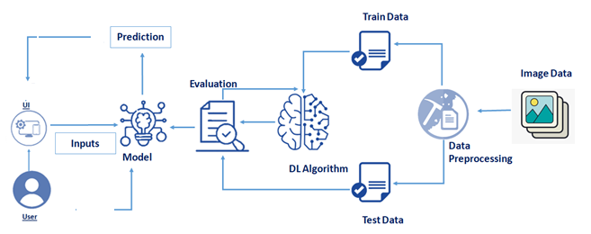

**Figure 2: Project architecture**

**4.2 USECASE DIAGRAM**

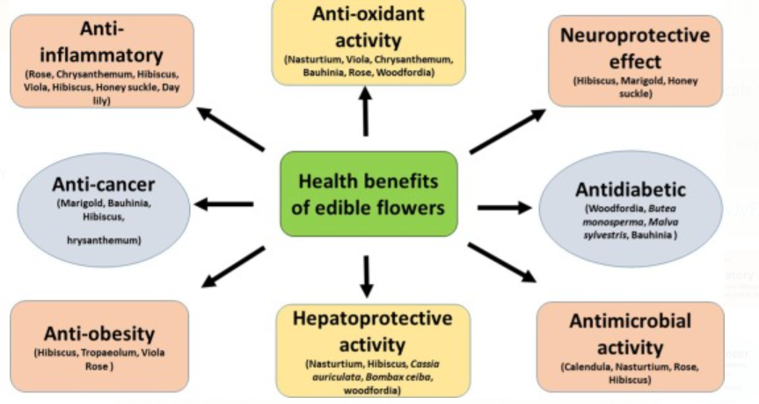

**Figure 3:Use case diagram**

### 4.3 SOFTWARE SPECIFICATIONS:

|  |  |
| --- | --- |
| **REQUIREMENT** | **SPECIFICATION** |
| Anaconda Navigator | You must have anaconda installed in your device prior to begin. |
| Spyder, Jupyter Notebook, Flask  Framework, deep learning software tools like keras,tensorflow | 1. One should have Spyder and Jupyter notebook. 2. One should install flask framework through anaconda prompt for running their web application 3. We need to build the model using jupyter notebook with all the imported packages. |
| Web browser | For all Web browsers, the following must be enabled:   * cookies * HTML * Java script |

### 4.4 HARDWARE SPECIFICATIONS:

|  |  |
| --- | --- |
| **REQUIREMENT** | **SPECIFICATIONS** |
| Operating system | Microsoft Windows  UNIX  Linux® |
| Processing | Minimum: 2 CPU cores for one user. For each deployment, a sizing exercise is highly recommended. |
| RAM | Minimum 8 GB. |
| Operating system specifications | File descriptor limit set to 8192 on UNIX and Linux |
| Disk space | A minimum of 7 GB of free space is required to install the software. |

### 4.EXPERIMENTALANALYSIS:-

Analysis or the investigation made while working on the solution:

While working on the solution we investigated on prediction of edibility of wild plants, IBM cloud, IBM Watson studio ,Convolution Neural Network(CNN) model, Cloud Object Storage. The key role on investigation is collection of datasets.

* 1. **IBM Cloud Account**:

IBM Acquired soft layer, a public cloud platform, to serve as the foundation for its IaaS offering. In October 2016, IBM rolled the soft layer brand under its Blue mix brand of PaaS offerings, giving users to access both IaaS and PaaS resources from a single console. IBM cloud provides a full-stack, public cloud platform with various products in the catalog, including options for compute, storage, networking, end to end developer solutions for app development, testing and deployment, security databases, and cloud native services.

### Creating the IBM cloud account by going to the IBM cloud login page and click create on IBM cloud account. Enter our IBM id and an ID is created based on the email that we enter. Completing the remaining fields with our information and click create account by this the account is created.

### 

* 1. **Dataset Pre-processing:**

The data pre-processing on images of wild plants is done by following steps:

* Import the Image Data Generator library
* Configure Image Data Generator class
* Apply Image Data Generator functionality to Train set and Test set
  1. **Model Building:**
* Import the model building Libraries
* Initializing the model
* Adding Input Layer
* Adding Hidden Layer
* Adding Output Layer
* Configure the Learning Process
* Training and testing the model
* Save the Model

**6.FLOW CHART:**

Loading data from the prepared dataset

Testing samples

Training samples

Convolution layer

Max pooling layer

Convolution layer

Max pooling layer

Convolution layer

Max pooling layer

CNN based feature learning network

Training samples features

Testing samples features

f

Evaluate the model

Save the model

END

DEPLOY MODEL ON IBM

**Figure 4: flow chart**

**7.1 MODELCODE:-**

**7.CODE SNIPPETS:-**

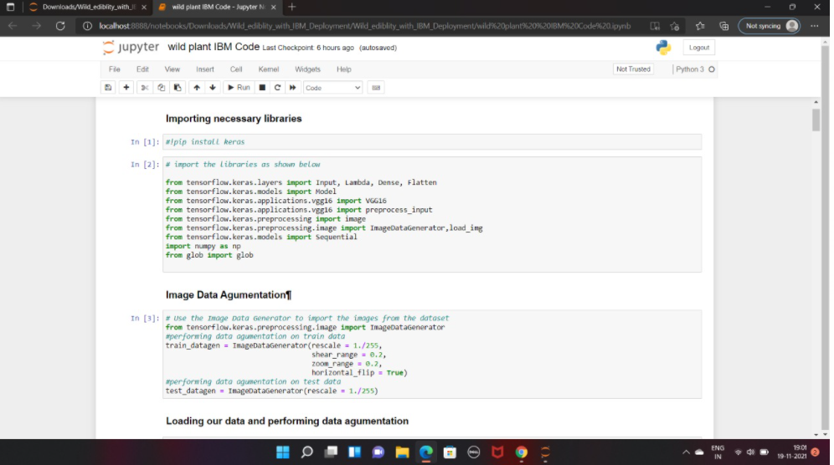

**Figure 5:ipynb code describing libraries and displaying few rows from dataset**

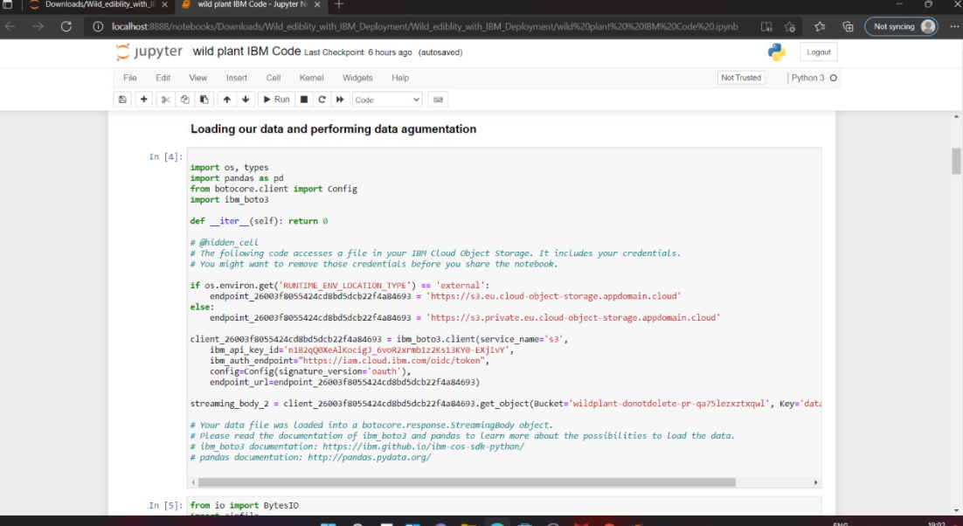

**Figure 6:ipynb describing the loading data perfomance**

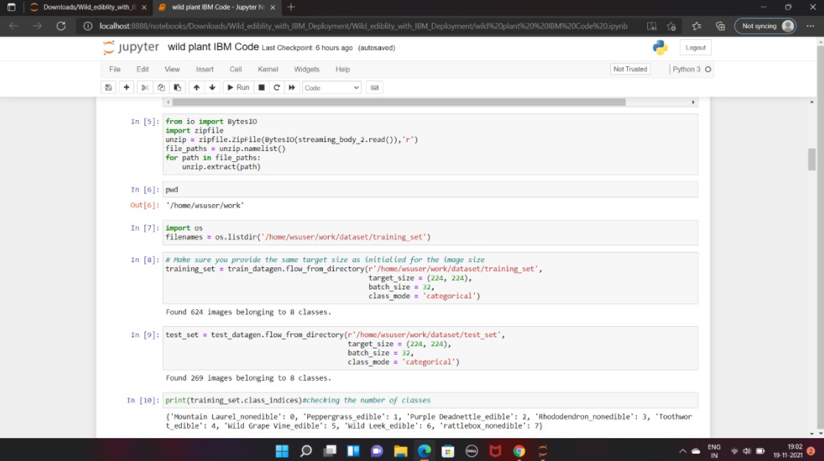

**Figure 7:ipynb code of data augmentation**

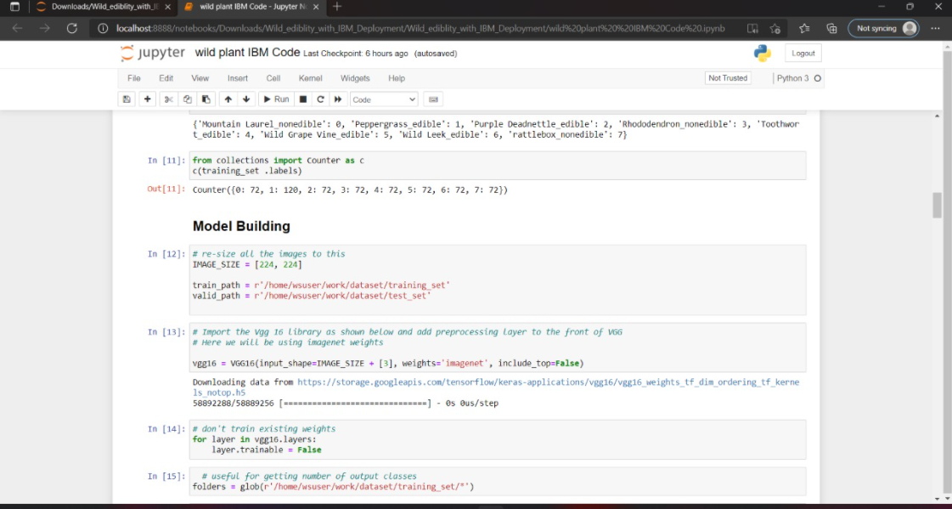

**Figure 8:ipynb describing the model building**

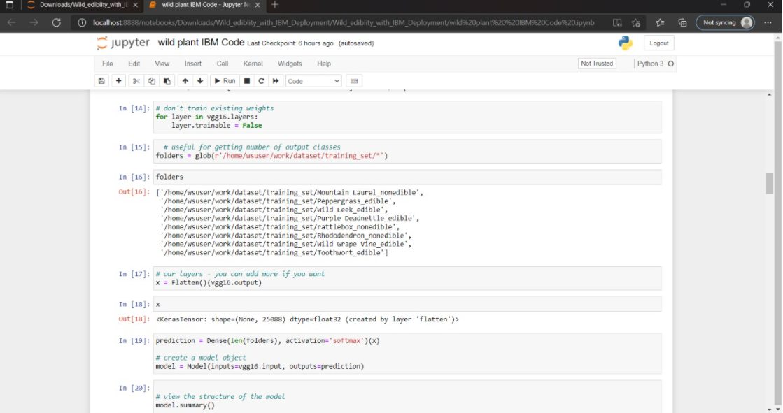

**Figure 9:ipynb describing the model building**

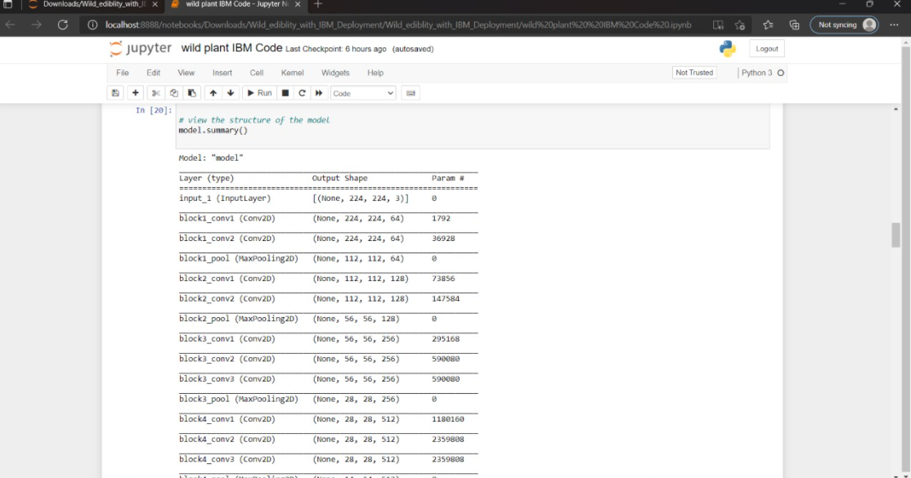

**Figure 10: ipynb describing the model building**

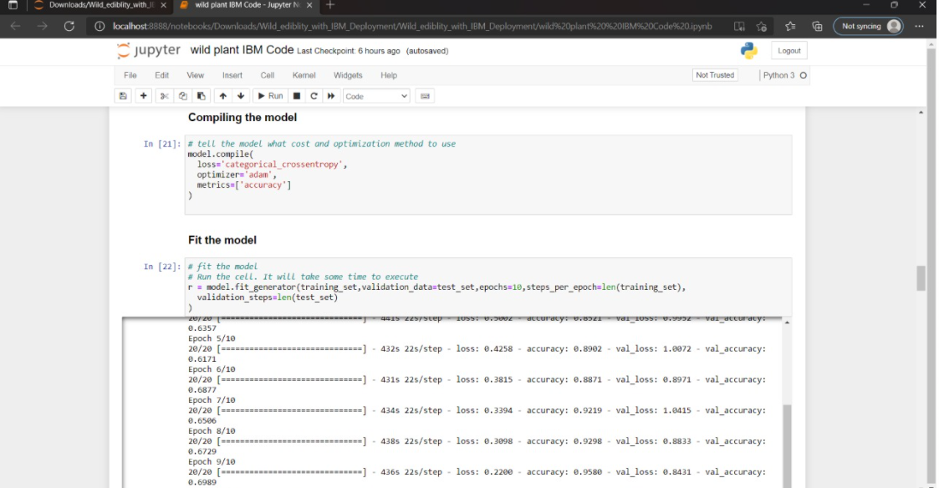

**Figure 11:ipynb code of compiling the model**

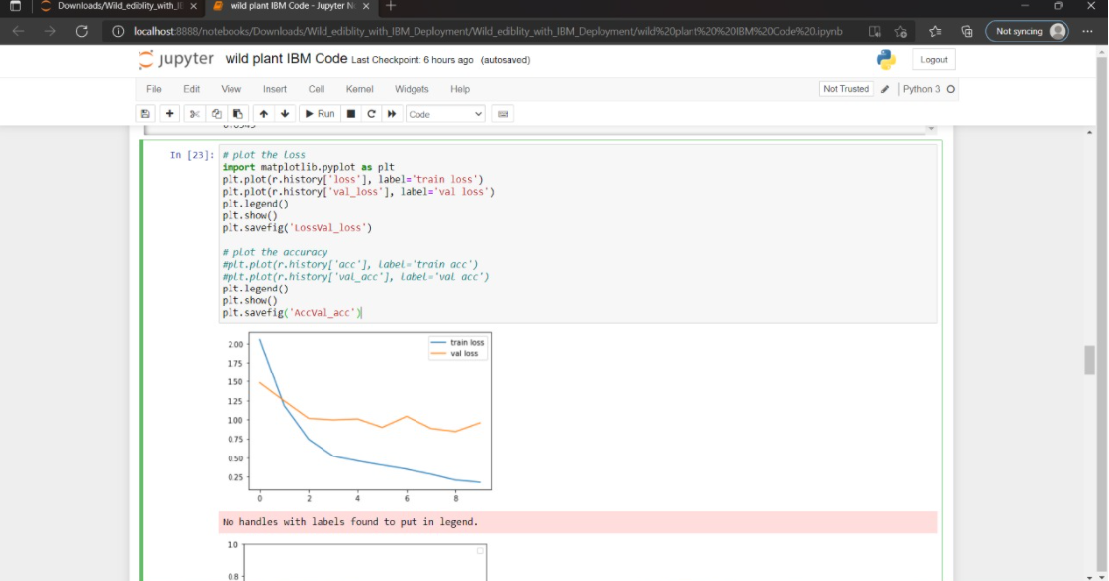

**Figure 12: ipynb code of describing the fit the model**

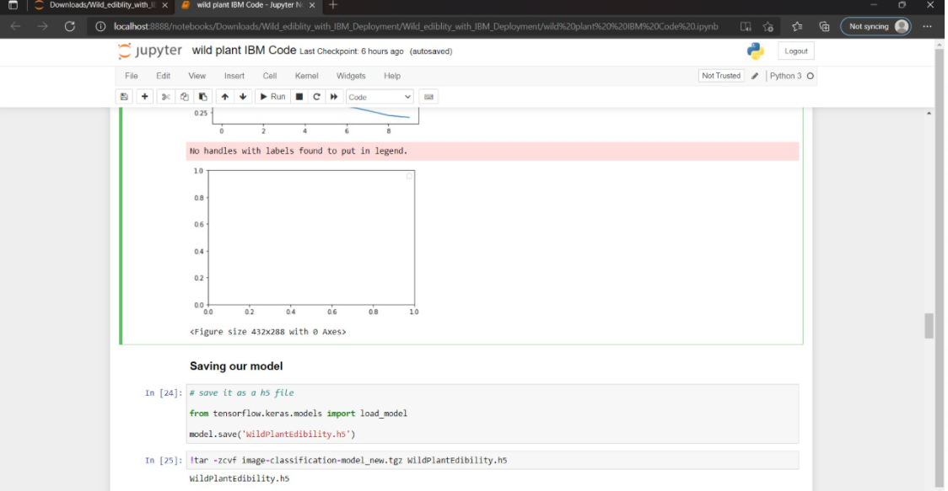

**Figure 13: Predicting the model**

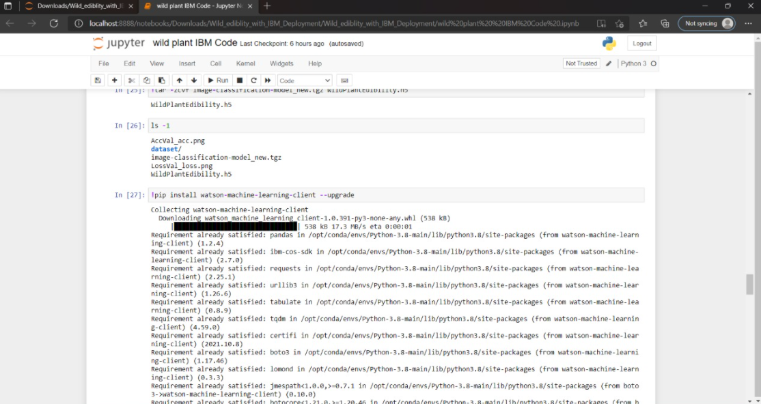

**Figure 14: Predicting the model**

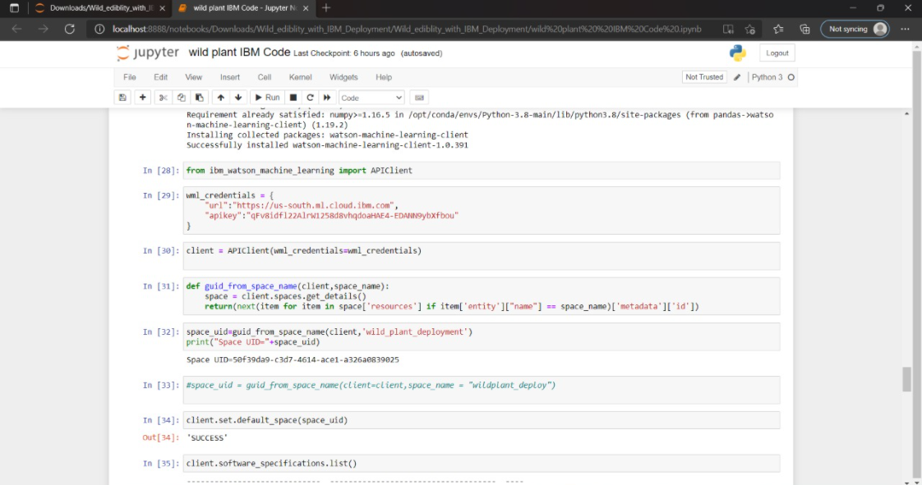

**Figure 15: saving the model**

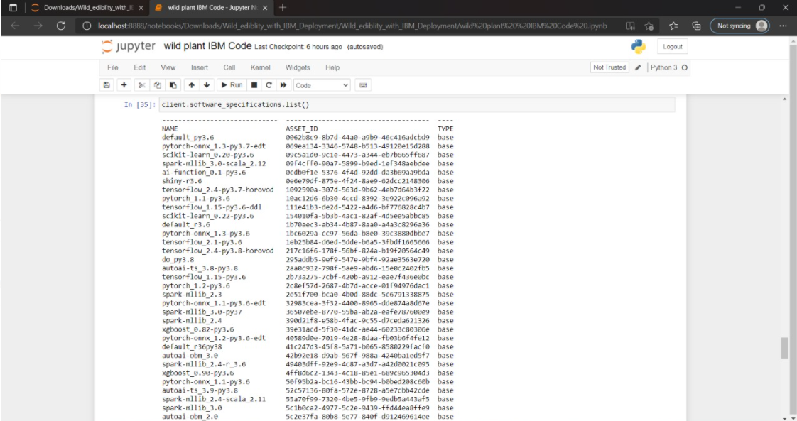

**Figure 16: styling the bodytag**

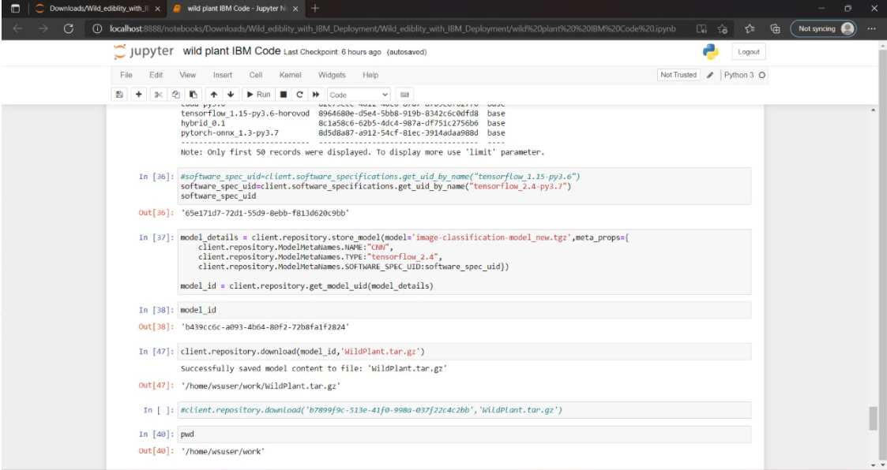

**Figure 17: Predicting the building model**

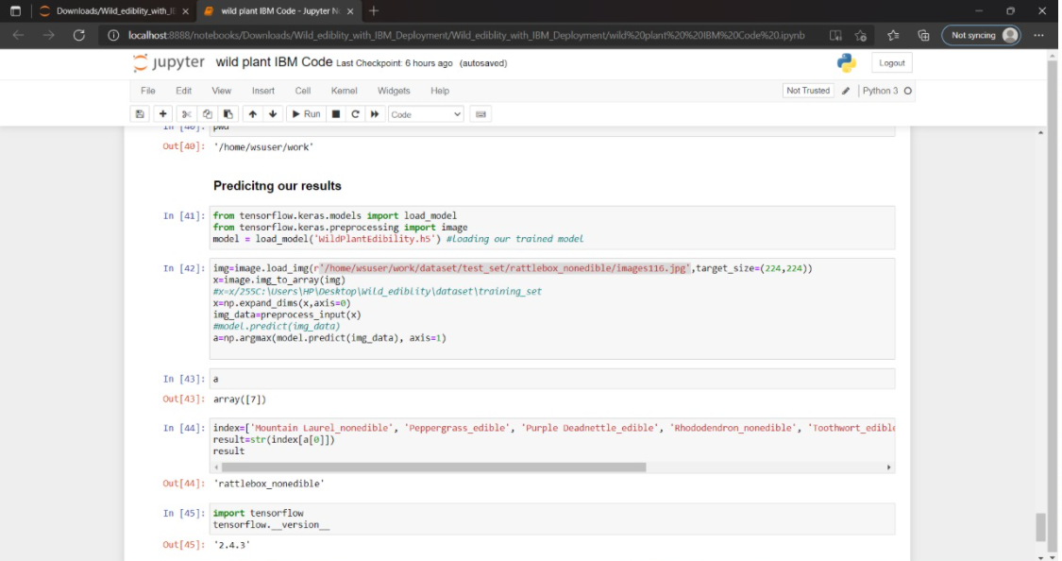

**Figure 18:ipynb code of predicting our results**

* 1. **HTML CODE OF INDEX:-**
* **INDEX.HTML**

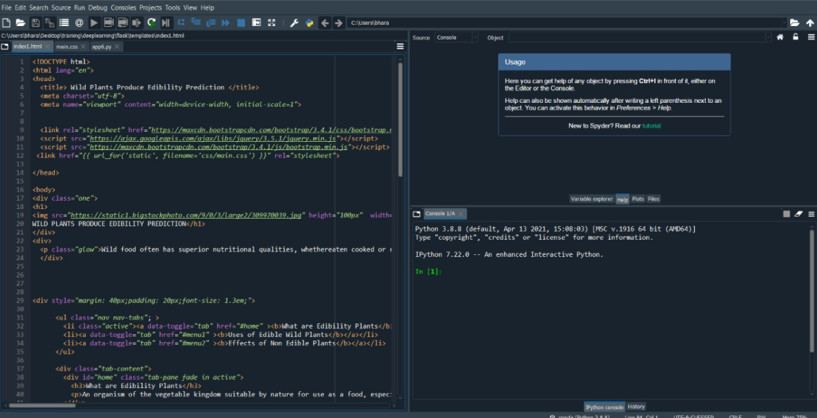

**Figure 19:html code**

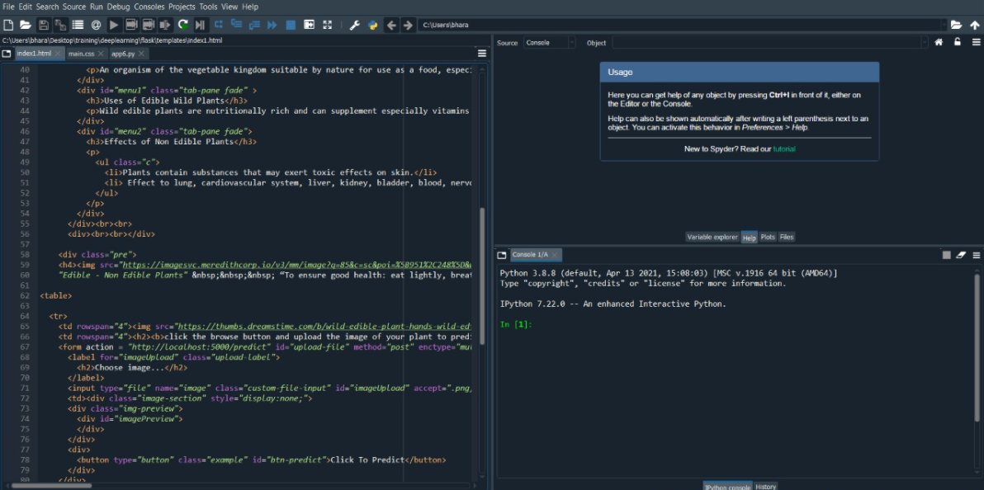

**Figure 20**

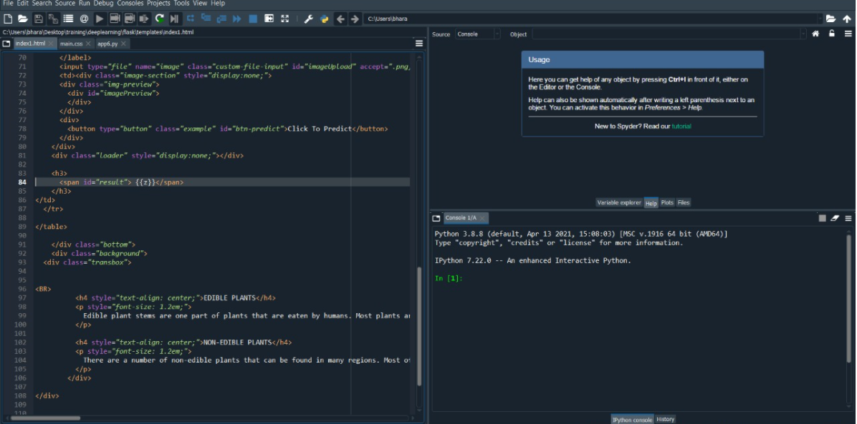

**Figure 21**

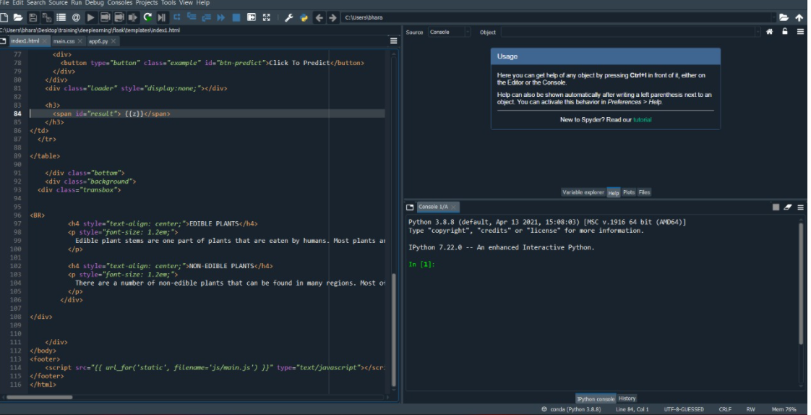

**Figure 22**

**CONCLUSION:-**

**From this entire finding we know fundamental concepts and can work on IBM Watson and machine learning.**

* In this project we have presented the Wild Plants Edibility Prediction
* We have done the Prediction using Deep Learning Techniques.
* For the better results we applied CNN layer and proved with 37% accuracy.

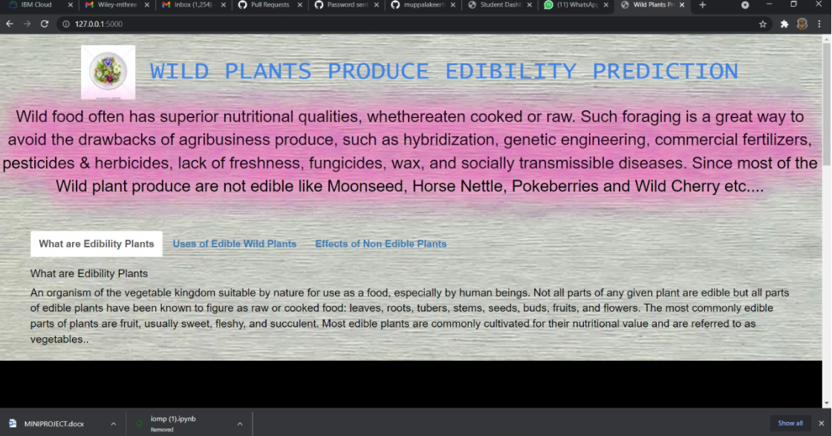

**Figure 23:wild plants produce edibility prediction**

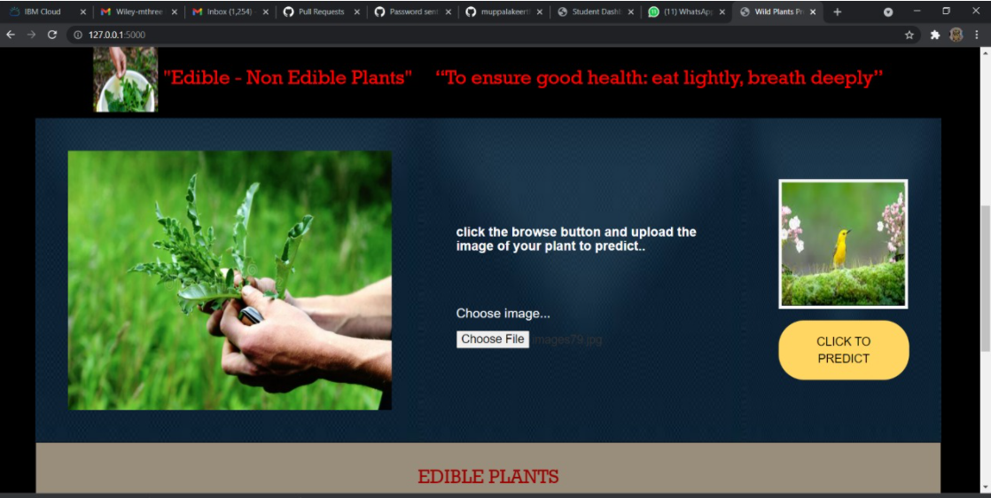

**Figure 24:To ensure good health of edible and non edible plants**

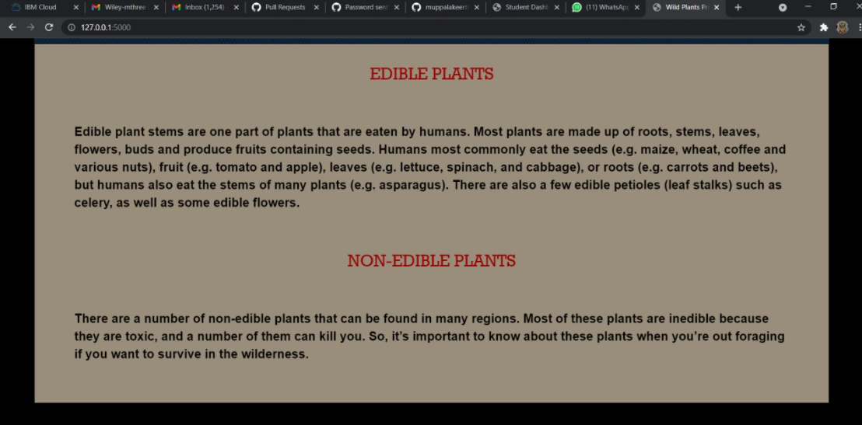

**Figure 25:edible plants and non edible plants**

## 

## Figure 26:Edibile and non edible plants of eat lightly

## 9.APPLICATION

## Wild plants food often has superior nutritional qualities, such as wild edible plants are nutrionally rich and can supplement especially vitamins and micronutrients .These shows that the wild plants are essential components of many cities diets ,especially in periods of seasonal food shortage.

# 10. ADVANTAGES

* An organization of the vegetable kingdom suitable by nature for use as a food, especially by human beings.
* The most commonly edible plants are fruits,usually sweet, fleshy and sufficient.
* Most edible palnts are commonly collect from their nutritional value and reffered to as vegetables.

**11.DISADVANTAGES**

* There are no.of non-edible plants that can be found in many regions.
* Effect of lungs ,kidneys and etc,

## 12.FUTURE SCOPE:-

**Enhancements that can be made in the future:**

* Wild plants are serving as supplementary foods for various rural communities.
* The model built with convolution neural networks detect and classifying edibility of wild plants.
* Our model also suggests the effects of non-edible wild plant procedure.

## 13.BIBLIOGRAPHY:-

* <https://smartinternz.com/Student/guided_projects>
* <https://www.kaggle.com/paultimothymooney/breast-histopathology-images>